**Step by Step Oracle 21c Installation On Linux**

[](https://oracledbwr.com/wp-content/uploads/2022/09/10.png)

**Description:-**

In this posting we are going to see the step by step Oracle 21c Database Installation on Linux.

**Note:-**

* Oracle Database 19c is the current long term release, and it provides the highest level of release stability and longest time-frame for support and bug fixes.
* Oracle Database 21c, also available for production use today as an innovation release, provides an early insight into the many enhancements and new capabilities.
* Oracle have announced there will be no 22c release, so the next release after 21c will be 23c, which will be the next long term release.
* If you are on 19c than you need to wait until 23c is released

**Step :-1 Download the database 21c software**

Once you’ve downloaded the software, unzip file to the oracle home directory. With Oracle 21c , you don’t need any staging directory. You can just unzip to Oracle Home.Here we have download Oracle 21.3 from the Oracle 21c linux [download page](https://www.oracle.com/database/technologies/oracle21c-linux-downloads.html).

**Step:-2 Create the new groups and users.**

[root@oracle21c ~]# groupadd -g 54321 oinstall  
[root@oracle21c ~]# groupadd -g 54322 dba  
[root@oracle21c ~]# groupadd -g 54323 oper  
[root@oracle21c ~]# useradd -u 54321 -g oinstall -G dba,oper oracle  
[root@oracle21c ~]# passwd oracle

**Step:-3 Create Oracle home directory and give ownership to Oracle user**

[root@oracle21c ~]# mkdir -p /u01/app/oracle/product/21.0.0.0  
[root@oracle21c ~]# chown -R oracle:oinstall /u01  
[root@oracle21c ~]# chmod -R 775 /u01

**Step:-4 Setup Oracle user bash_profile**

[oracle@oracle21c ~]$ cat .bash_profile  
export ORACLE_BASE=/u01/app/oracle  
export ORACLE_HOME=/u01/app/oracle/product/21.0.0.0  
export ORACLE_SID=TEST  
export PATH=/usr/sbin:$PATH  
export PATH=$ORACLE_HOME/bin:$PATH  
export LD_LIBRARY_PATH=$ORACLE_HOME/lib:/lib:/usr/lib  
export CLASSPATH=$ORACLE_HOME/jlib:$ORACLE_HOME/rdbms/jlib

**Step:-4 Copied the Oracle Software and unzip**

[oracle@oracle21c 21.0.0.0]$ cd  
[oracle@oracle21c ~]$ cd /u01/app/oracle/product/21.0.0.0/  
[oracle@oracle21c 21.0.0.0]$ ls -lrt  
total 3036356  
-rwxrwxr-x. 1 oracle oinstall 3109225519 Aug 24 00:10 **LINUX.X64_213000_db_home.zip**

[oracle@oracle21c 21.0.0.0]$ unzip LINUX.X64_213000_db_home.zip

**Step:-5 Start the installation**  
Open an X-Windows session to the server as the “oracle” user.

/u03/app/oracle/product/21.0.0.o/runInstaller  
Once the GUI starts, respond as follows:

[oracle@oracle21c ~]$ cd /u01/app/oracle/product/21.0.0.0/  
[oracle@oracle21c 21.0.0.0]$ ./runInstaller

Click on Setup Software Only and then do Next

[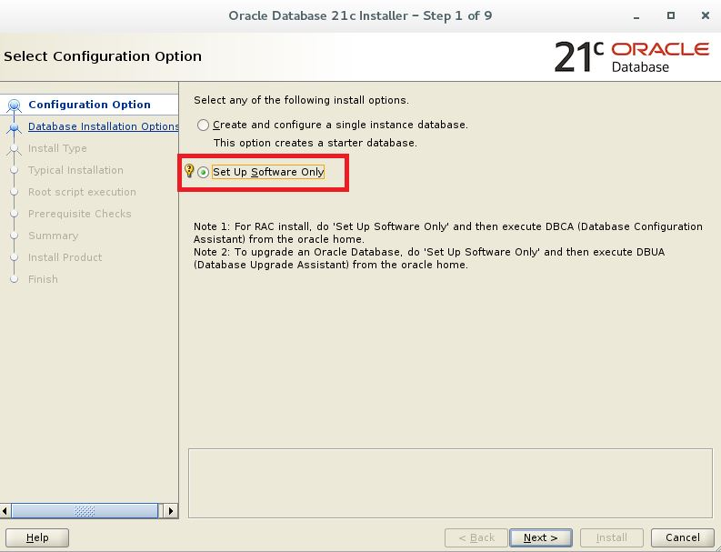](https://oracledbwr.com/wp-content/uploads/2021/09/1.jpg)

Click on Single Instance database installation and click Next

[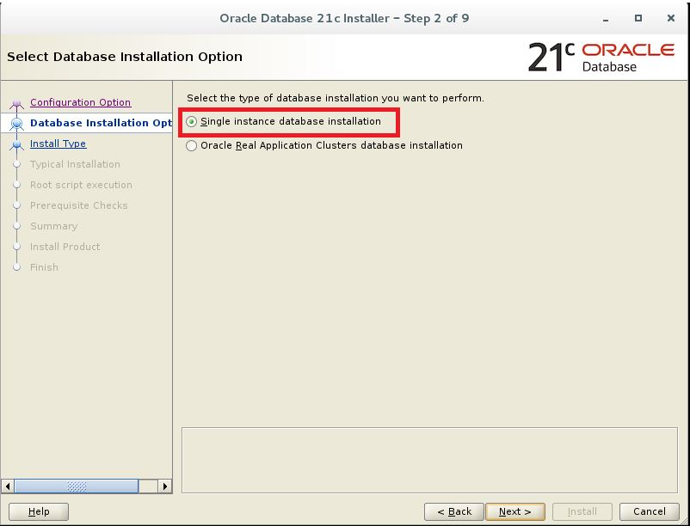](https://oracledbwr.com/wp-content/uploads/2021/09/2.jpg)

Click on Type of edition you require and then click next-choose Enterprise Edition

[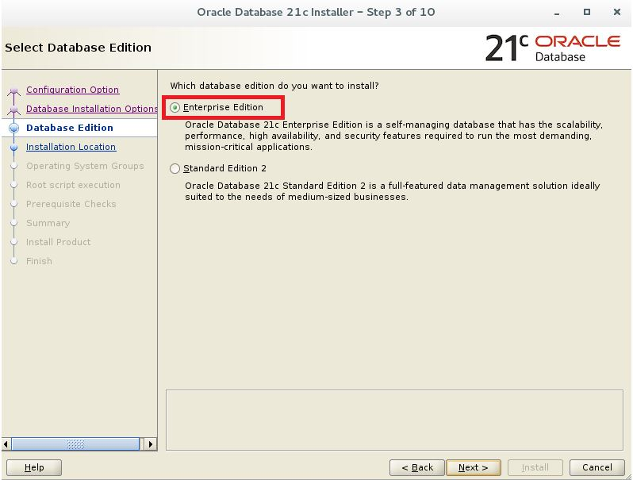](https://oracledbwr.com/wp-content/uploads/2021/09/3.jpg)

Check the Oracle Base Location and then click next

[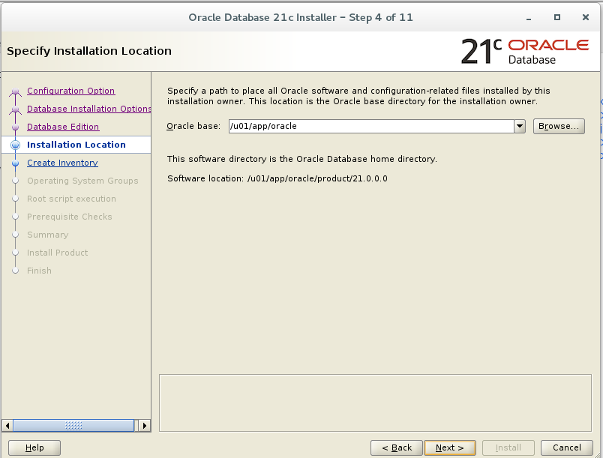](https://oracledbwr.com/wp-content/uploads/2022/09/2.png)

Choose the default and click next

[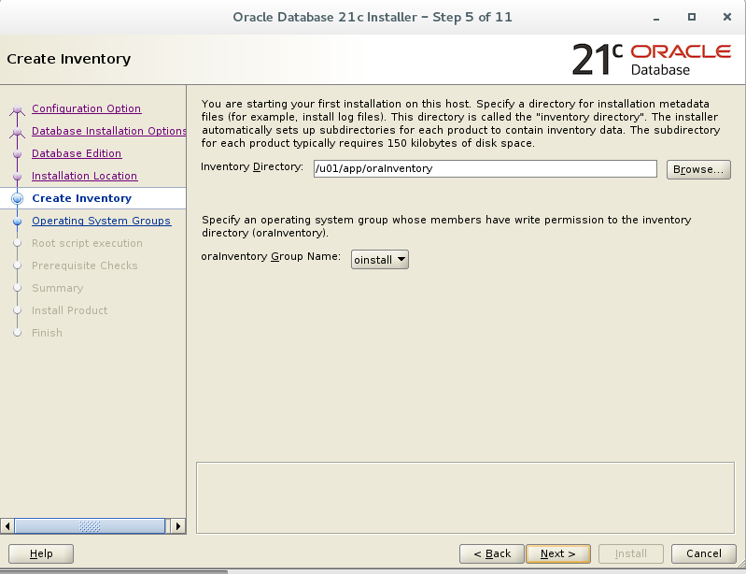](https://oracledbwr.com/wp-content/uploads/2022/09/3.png)

[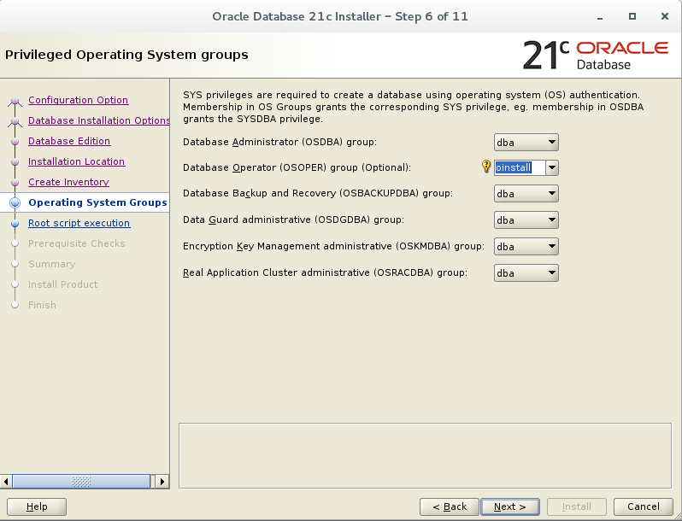](https://oracledbwr.com/wp-content/uploads/2022/09/4.png)

We can choose to run the root.sh from installation only by providing the root password or sudo information. Here we choose to take the manual root.sh and just click Next

[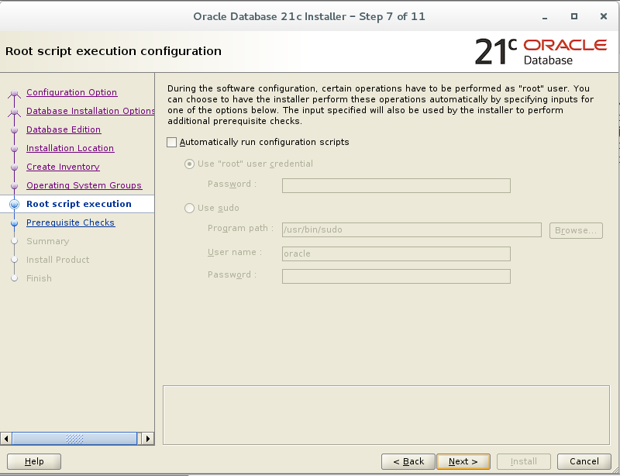](https://oracledbwr.com/wp-content/uploads/2022/09/5.png)

Perform Prerequisite Checks

[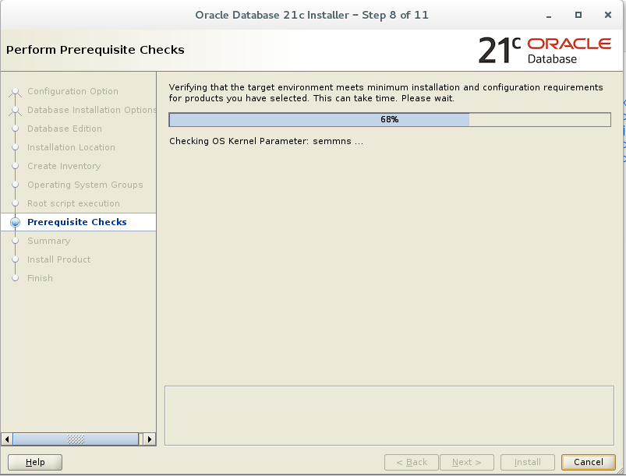](https://oracledbwr.com/wp-content/uploads/2022/09/6.png)

Summary

[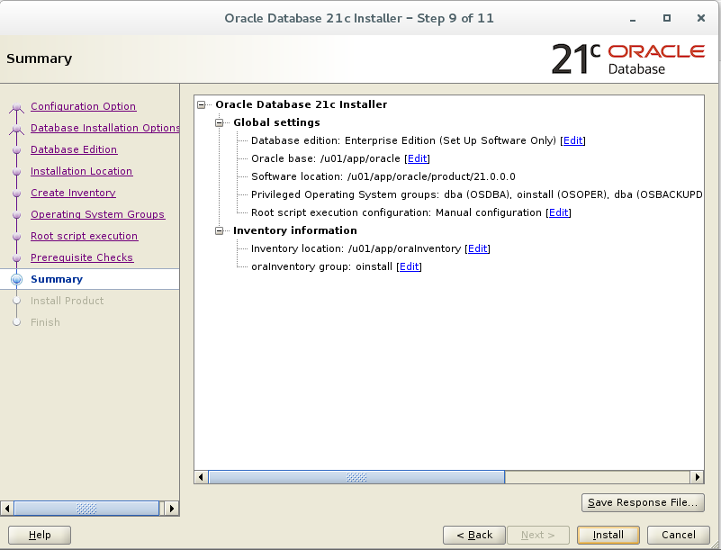](https://oracledbwr.com/wp-content/uploads/2022/09/7.png)

Run the root scripts when prompted.

As a root user, execute the following script(s):

**/u01/app/oraInventory/orainstRoot.sh**

**/u01/app/oracle/product/21.0.0.0/root.sh**

[root@oracle21c ~]# /u01/app/oraInventory/orainstRoot.sh  
Changing permissions of /u01/app/oraInventory.  
Adding read,write permissions for group.  
Removing read,write,execute permissions for world.  
Changing groupname of /u01/app/oraInventory to oinstall.  
The execution of the script is complete.

[root@oracle21c ~]# /u01/app/oracle/product/21.0.0.0/root.sh  
Performing root user operation.  
The following environment variables are set as:  
ORACLE_OWNER= oracle  
ORACLE_HOME= /u01/app/oracle/product/21.0.0.0  
Enter the full pathname of the local bin directory: [/usr/local/bin]:  
Copying dbhome to /usr/local/bin …  
Copying oraenv to /usr/local/bin …  
Copying coraenv to /usr/local/bin …  
Creating /etc/oratab file…  
Entries will be added to the /etc/oratab file as needed by  
Database Configuration Assistant when a database is created  
Finished running generic part of root script.  
Now product-specific root actions will be performed.

[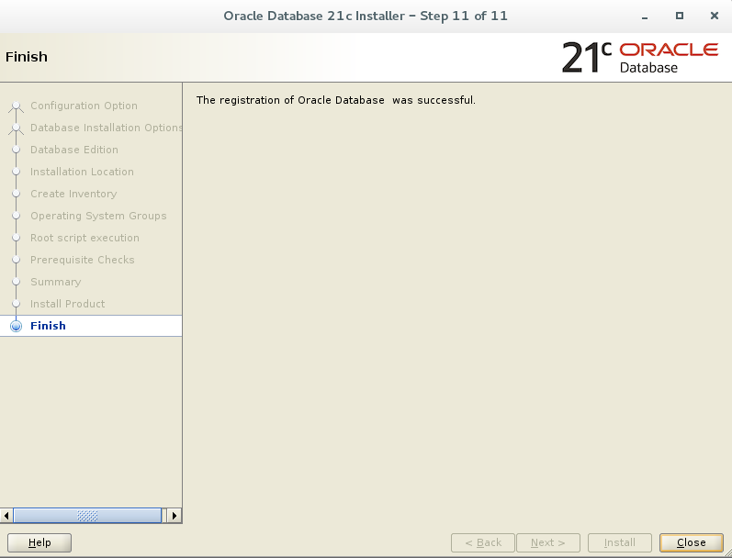](https://oracledbwr.com/wp-content/uploads/2022/09/9.png)

We have successfully completed the Oracle Database 21c Installation On Oracle Linux 7 (OL7).